INDOOR NAVIGATION WITH TURTLEBOT

# INTRODUCTION

This report describes the configuration and use of a TurtleBot3 for precise room navigation as part of an ongoing effort to improve self-driving robots. It is the robot's responsibility to autonomously map its environment, identifying obstructions and barriers. Additionally, two distinct colored objects that are positioned in the room at designated points A and B should be recognized by the system. Using a Python script, the user is asked to input point A or point B, based on their choice. The robot's task is to go to the assigned points, count the boxes in color (blue or pink) on an A4 sheet, and show the total number of colored objects. This comprehensive method aims at showcasing the robot's whole integration of mapping, object identification, and user interaction.

# ALGORITHM DESCRIPTION

The provided set of commands shows the steps to connect a TurtleBot3 robot to a computer, perform SLAM (Simultaneous Localization and Mapping), save a map, set up a camera, launch the camera, and view the camera image. Additionally, it includes a step to find the robot's coordinates using the odometry topic.

1. **Connect to the TurtleBot3 Robot:** We ran the ROS master core: $ roscore. Then we connected to the TurtleBot3 via SSH using the specified IP address and password.
   * $ ssh ubuntu@192.168.0.160
   * password: turtlebot
2. **Launch TurtleBot3 Bringup in the same terminal:**

* $ roslaunch turtlebot3_bringup turtlebot3_robot.launch

1. **SLAM (Simultaneous Localization and Mapping):** - We then launched SLAM with the GMapping method:
   * roslaunch turtlebot3_slam turtlebot3_slam.launch slam_methods:=gmapping
2. **Move Base and AMCL:**

Launch move_base for path planning:

* + $ roslaunch turtlebot3_navigation move_base.launch

Launch AMCL for localization:

* + $ roslaunch turtlebot3_navigation amcl.launch

1. **Explore Lite (Autonomous Exploration)**:- Launch the explore_lite package with auto-start enabled:
   * $ roslaunch explore_lite explore.launch auto_start:=true
2. **Save Map**: - Run the map_saver to save the generated map:
   * $ rosrun map_server map_saver -f ~/maptest477

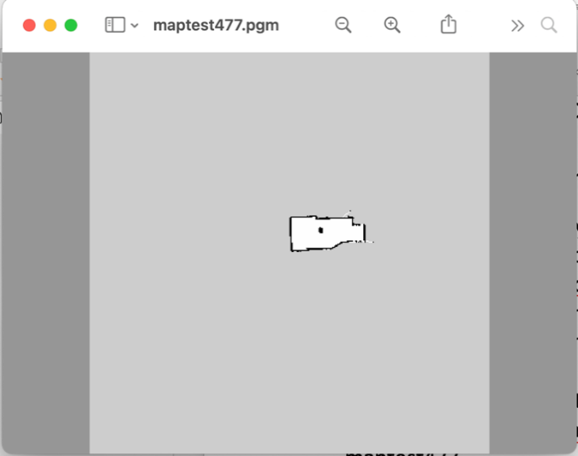

**Figure 1: Map of the room**

1. **Camera Setup**:- To Connect to the TurtleBot3 via SSH and update packages:
   * $ ssh [ubuntu@192.168.0.160](mailto:ubuntu@192.168.0.160) (password: turtlebot)

* $ sudo apt update

1. **Launch the USB camera in the same terminal:**

* $ roslaunch /opt/ros/noetic/share/usb_cam/launch/usb_cam-test.launch

1. **Check topics and view the camera image using**

* $ rostopic list and $ rqt_image_view.
* $ rosrun image_view image_view image:=/usb_cam/image_raw

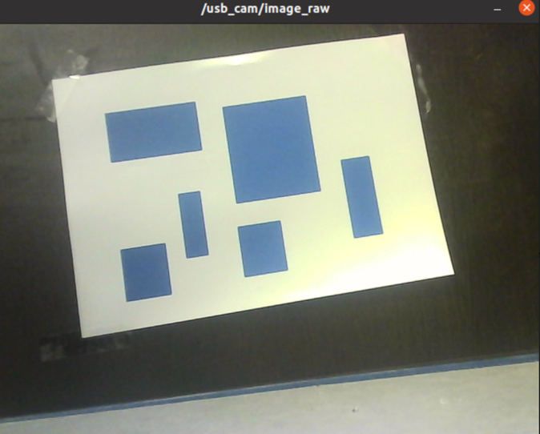 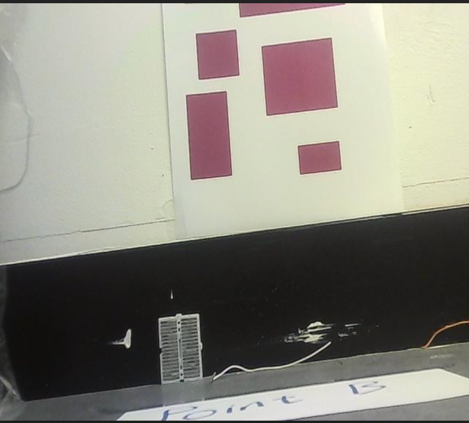

**Figure 2 and 3 : Camera image at Point A and B**

1. **Odometry Coordinates:-** We got the robot's its coordinates:

* $ rostopic echo /odom

The commands which are related to the robot through ssh are:

$ roslaunch turtlebot3_bringup turtlebot3_robot.launch

$ roslaunch /opt/ros/noetic/share/usb_cam/launch/usb_cam-test.launch

# COLOR DETECTION

The python script performs color-based blob detection and counting using the open cv library.

1. **Function Definition**(process_image): this takes the image path, lower and upper color thresholds, the blob area, and color name as inputs. It then loads the image provided and converts it to the HSV value, it creates the color mask based on the HSV values specified. This is done through the terminal using the images that the camera captured.

* $python3 ./range_detect.py -f HSV -i pink.jpg -p
* $python3 ./range_detect.py -f HSV -i blue.jpg -p

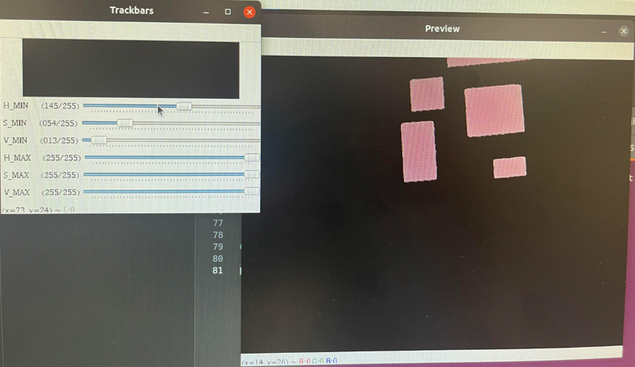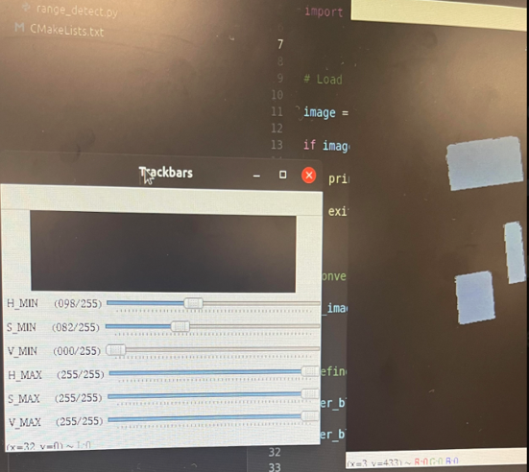  
**Figure 4 and 5 : HSV values of Blue and Pink**

|  |  |
| --- | --- |
| BLUE | PINK |
| Lower H: 098  Upper H: 255 | Lower H: 145  Upper H: 255 |
| Lower S: 082  Upper S: 255 | Lower S: 54  Upper S: 255 |
| Lower V: 00  Upper V: 255 | Lower V:13  Upper V: 255 |

It then finds the contours in the mask, representing the connected components of the specified color. The code then iterates through the contours, filters the blobs based on the minimum area and draws bounding boxes around the blobs. It then prints the number of identified blobs and displays the original image with the bounding boxes around the blobs.

1. **User Input and Image Processing:** It prompts the user to choose between a blue or pink image by entering A or B. It uses the input().upper() method to read the user’s input in uppercase . It then calls the process_image function with the right parameters based on the user’s input and specifies the color threshold and minimum blob area for blue and pink blobs.
2. **Image Display:** It displays the processed image with the bounding boxes for a duration of 60 seconds using cv2.imshow. It then exits the program after waiting for the user input in case of an invalid choice during image display.

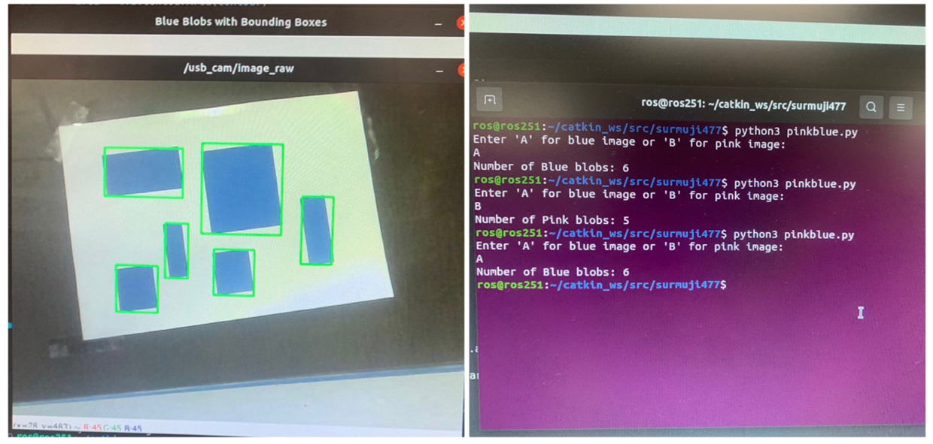

**Figure 6: Image Display with Bounding Boxes (Blue)**

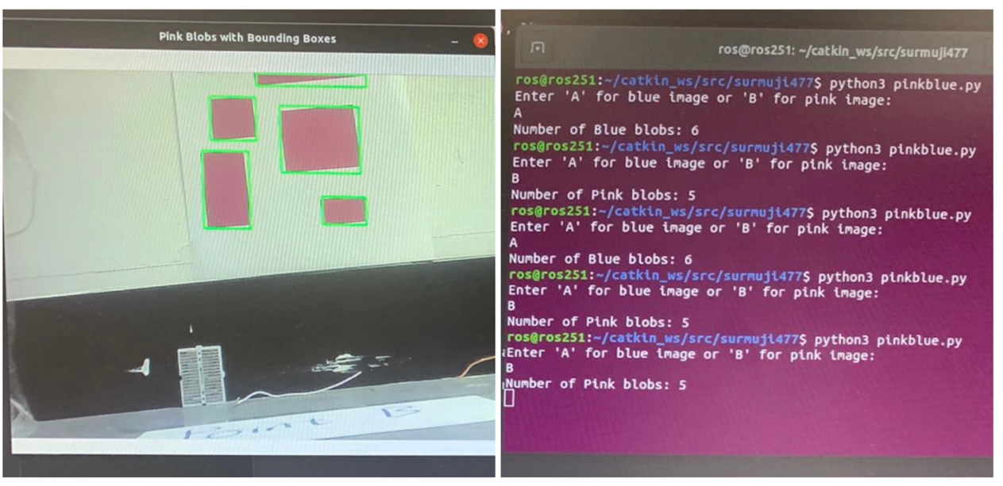

**Figure 7: Image Display with Bounding Boxes (Pink)**

# PYTHON SCRIPT DESCRIPTION

This python script incorporates image processing, odometry and image capturing and user interaction.

1. **ROS Node Initialization:**

* The script starts by initializing a ROS node named 'turtlebot3_navigation'.

1. **Class Definition:** TurtleBot3Navigation:

* The class contains methods to control the TurtleBot3's navigation and image processing.

1. **Initialization** (__init__ method):

* Initializes ROS node, sets up variables, and subscribes to the odometry topic (‘/odom’) to get the current pose of the robot.

1. **User Input and Callback** (user_choice_callback method):

* Asks the user to input 'A' or 'B' to choose a destination.
* Calls move_to_goal method based on the user's choice.

1. **Odometry Callback** (odom_callback method):

* Updates the current pose of the robot whenever a new odometry message is received.

1. **Move to Goal** (move_to_goal method):

* Takes coordinates (x, y), orientation (z, w), color range, and other parameters as input.
* Publishes a navigation goal to the /move_base_simple/goal topic to move the robot to the specified location.
* Waits for the robot to reach the goal and then calls take_snapshot method.

1. **Take Snapshot** (take_snapshot method):

* Waits for the robot to stabilize.
* Captures an image from the USB camera (/usb_cam/image_raw topic) using OpenCV and saves it with a timestamp.

1. **Process Image** (process_image method):

* Loads the captured image and converts it to the HSV color space.
* Creates a color mask based on the specified color range.
* Finds contours in the mask and filters them based on the minimum blob area.
* Draws bounding boxes around the filtered blobs and displays the result using OpenCV.
* Print the count of blobs and waits for 60 seconds before closing the image window.

1. **Main Execution** (__main__block ):

* Creates an instance of the TurtleBot3Navigation class and starts the ROS node with rospy.spin().

1. **Exception Handling**:

* Catches the rospy.ROSInterruptException to handle interruptions.

This script essentially allows the TurtleBot3 to navigate to predefined goals ('A' or 'B'), take a snapshot upon reaching the goal, and process the captured image to count and display blobs of a specified color within a certain area range. The code relies heavily on the ROS framework for communication between different components of the robot and OpenCV for image processing.

# LAUNCH FILE

**$ roslaunch project477 navigation.launch: to launch the launch file**

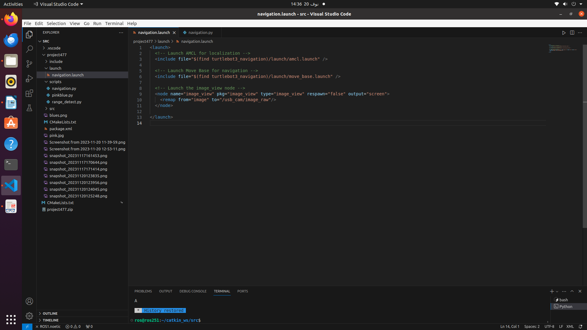

**Figure 8: Launch File**

This ROS launch file initiates the localization and navigation components for the launch files. Turtlebot3 robot by including the AMCL and Move Base launch files. Additionally, it launches the image_view node, a tool for viewing images, directing the node to subscribe to the usb_cam/image_raw topic to show the USB camera in real time on the screen. The respawn is set to false to ensure the image_view does not automatically restart when it is terminated.

# POSITION STORING DESCRIPTION

The code uses the current_pose variable to store the current pose (position and orientation) of the TurtleBot3 robot. The pose information is obtained from the odometry messages received on the /odom topic: **$ rostopic echo /odom**

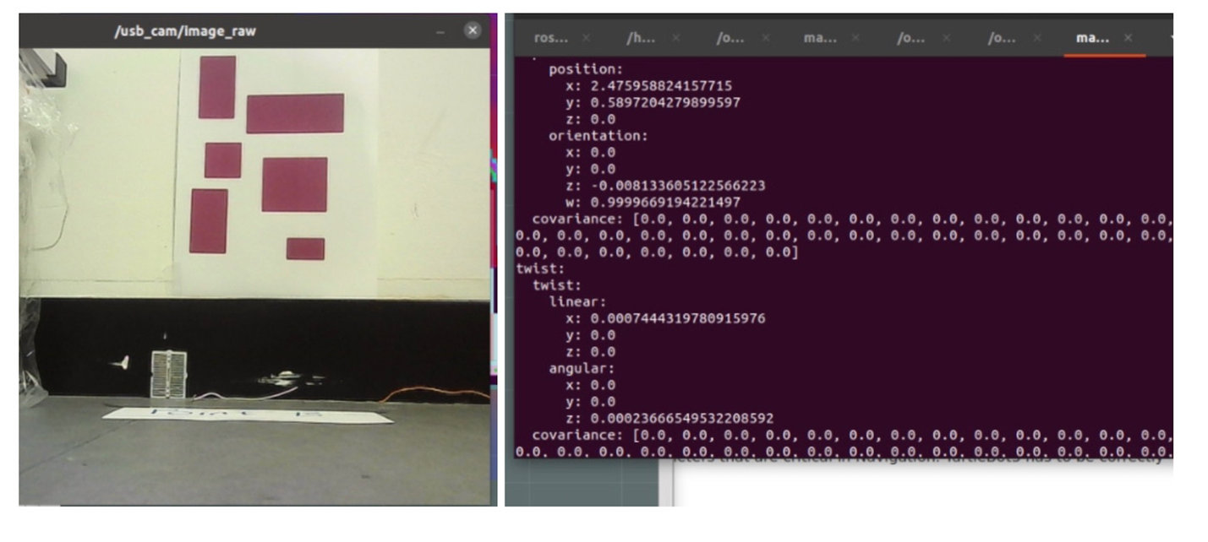

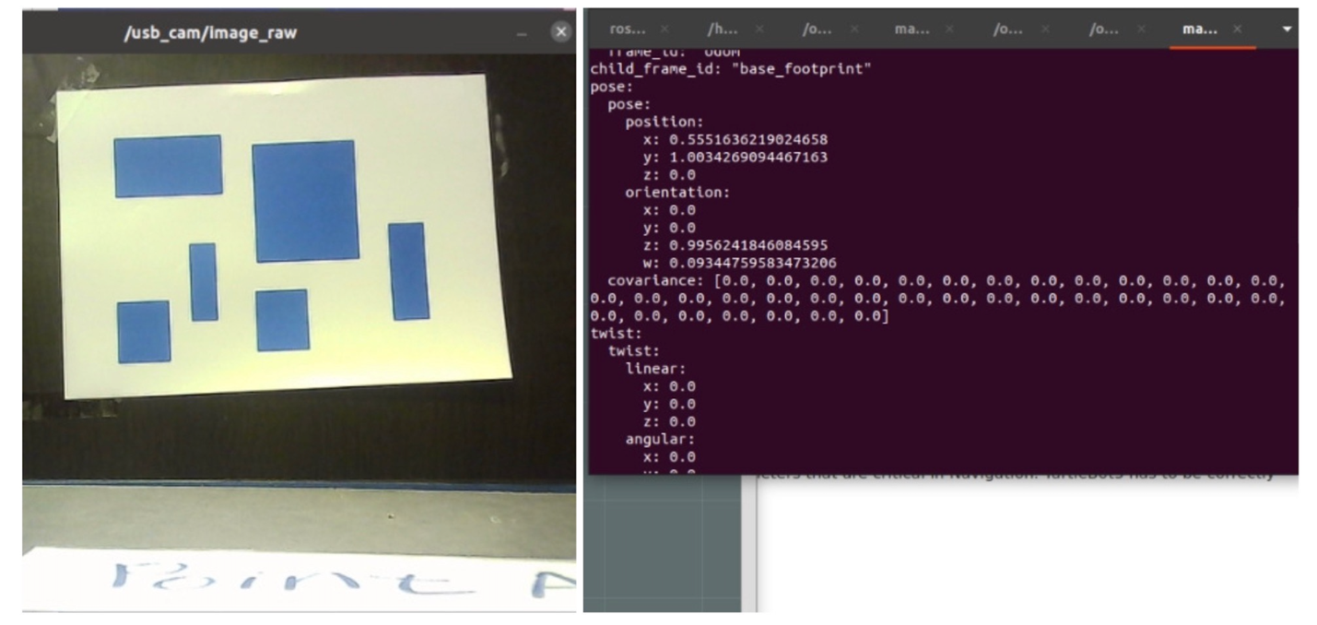

**Figure 8 and 9 : Odometry Values(Point A and B)**

|  |  |  |
| --- | --- | --- |
| **COLOR** | **POSITION** | **ORIENTATION** |
| Blue | X= 0.5551636219024658  Y= 1.0034269094467163  Z= 0 | Z=0.9956241846084595  W= 0.09344759583473206 |
| Pink | X= 2.475958824157715  Y= 0.5897204279899597  Z=0 | Z=-0.0081336051225566223  W= 0.9999669194221497 |

1. **Variable Initialization:** At the beginning of the TurtleBot3Navigation class, the **__init__** method initializes the self.current_pose = None. This variable will be used to store the current pose of the robot.
2. **Odometry Callback (odom_callback method):** The script subscribes to the /odom topic to receive odometry messages. The odom_callback method is called whenever a new odometry message is received.

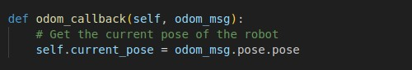

**Figure 10: Odometry Callback method**

Inside the odom_callback method, the pose information is extracted from the received odometry message (odom_msg). The pose.pose attribute of the odometry message contains the position and orientation information. This information is then stored in the self.current_pose variable. In the move_to_goal method, the goal pose is published to the (/move_base_simple/goal) topic for navigation. Before publishing the goal, the script waits for a brief period to allow the self.current_pose variable to be updated with the most recent odometry information.

1. **Usage in Move to Goal (move_to_goal method):**

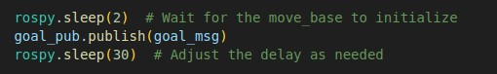

**Figure 11: Move to goal method**

The self.current_pose variable is used to store the current pose of the robot, allowing the script to have an updated position before sending a navigation goal.

1. **Accessing Current Pose:** The variable self.current_pose may be used throughout the script to obtain the TurtleBot3's current position and orientation. These values can be utilized in many areas of the script, such as defining the navigation objective pose or any other task that requires knowledge of the robot's present location and orientation.

Therefore, anytime new odometry signals are received, the current_pose variable is changed using the odom_callback method. This data is then utilized by the script to provide the most recent location and orientation of the TurtleBot3 for navigation and other activities.

# RESULTS

After running the following commands these are the results, showing the map on RVIZ, the camera image in real time and how many pink or blue boxes are printed on the paper.

New terminal: $ roscore

New terminal: $ ssh [ubuntu@192.168.0.160](mailto:ubuntu@192.168.0.160) (**Password:**turtlebot)

New terminal: $ roslaunch turtlebot3_navigation turtlebot3_navigation.launch map_file:=$HOME/maptest477.yaml

New terminal: $ roslaunch project477 navigation.launch

**To open the camera:**

New terminal: $ssh [ubuntu@192.168.0.160](mailto:ubuntu@192.168.0.160)

$roslaunch/opt/ros/noetic/share/usb_cam/launch/usb_cam-test.launch

New terminal: $/bin/python3/home/ros/catkin_ws/src/project477/scripts/main.py

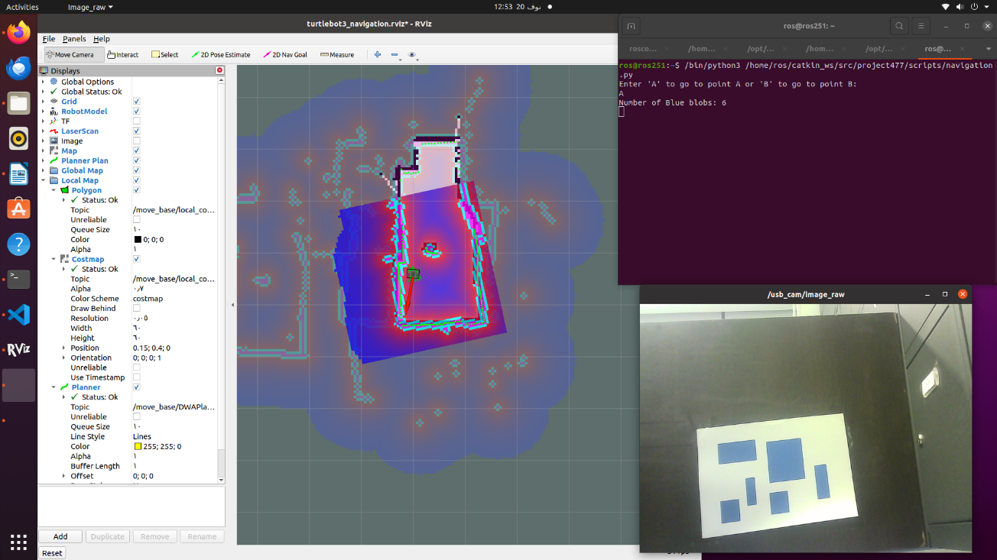

**Figure 12: Picture of the final map, user interaction and image (Blue)**

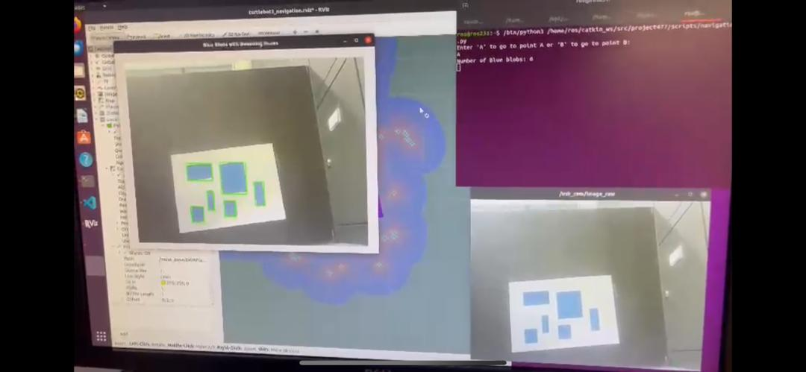

**Figure 13: Picture of the final map, user interaction and image with bounding box**



**Figure 14: Display of number of blue blobs**

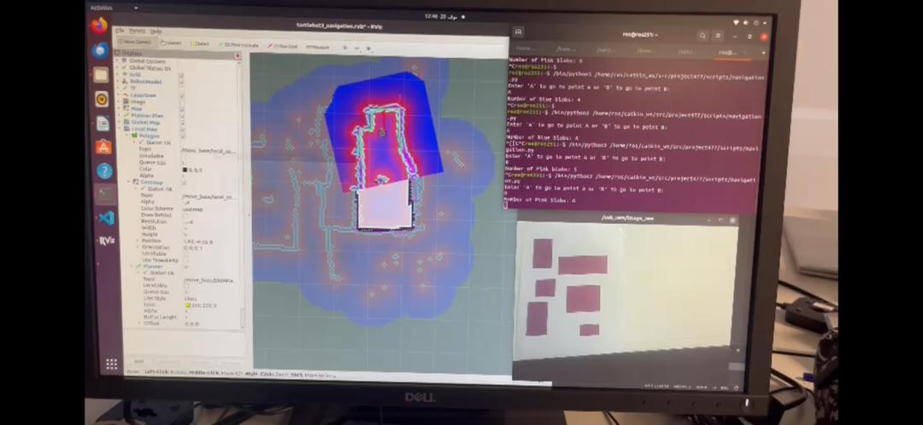

**Figure 15: Picture of the final map, user interaction and image (Pink)**

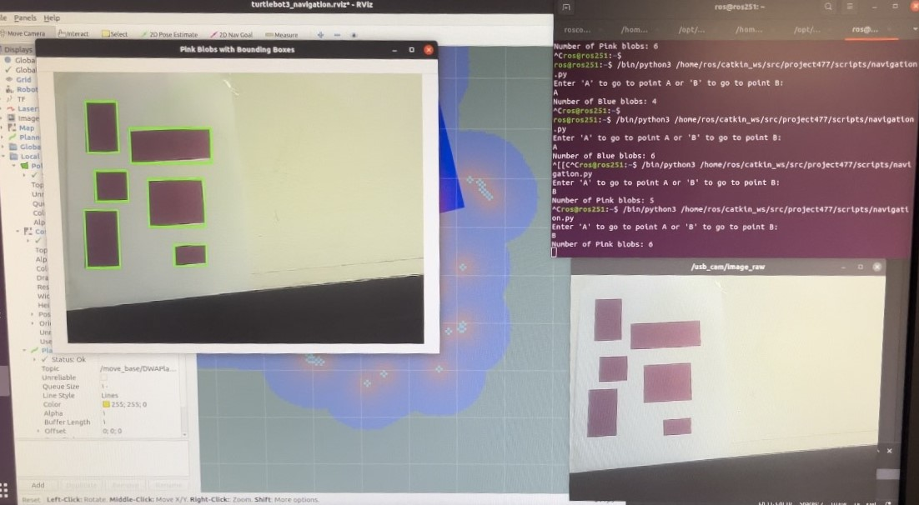

**Figure 16: Picture of the final map, user interaction and image with bounding box (Pink)**



**Figure 17: Display of number of pink blobs**

# CONCLUSION

In conclusion, the Python script given demonstrates the integration of navigation and image processing capabilities for the TurtleBot3 robot within the ROS framework. The use of odometry data guarantees that the current_pose variable is constantly updated, allowing for exact tracking of the robot's location and orientation. The Move Base package performs user-choice navigation ('A' or 'B'), demonstrating the robot's flexibility to various jobs. Furthermore, the script includes a launch file (navigation.launch), a critical component of ROS, to effortlessly establish the node and configure the robot's parameters. Beyond navigation, the TurtleBot3 takes and analyzes pictures using the USB camera and OpenCV, demonstrating its adaptability and expertise in performing numerous activities in a ROS environment.

# REFERENCES

Name, Y. (2019). *ROBOTIS*. [online] ROBOTIS e-Manual. Available at: https://emanual.robotis.com/docs/en/platform/turtlebot3/overview/ [Accessed 21 Nov. 2023].

‌Zynk (2016). *OpenCV & Python - Image too big to display*. [online] Stack Overflow. Available at: https://stackoverflow.com/questions/35180764/opencv-python-image-too-big-to-display [Accessed 21 Nov. 2023].

‌